**Digital Marketing Assignment -1**

|  |  |
| --- | --- |
| Student Name | Gopalakrishnan G |
| Student Register Number | 953720106007 |
| College Name | AAA College of Engineering and Technology |
| Naan Mudhalvan ID | 8D8AE28DABD77F8978942F9E1A96DC9A |

**Assignment:**

Create a blog or website using Blogpost and WordPress. Customize the theme design and post new article with 500 words.

**Solution:**

1.BlogPost

Link: <https://phoenixfashion73.blogspot.com/2023/08/phoenix-fashions-guide-to-mens-wear.html>

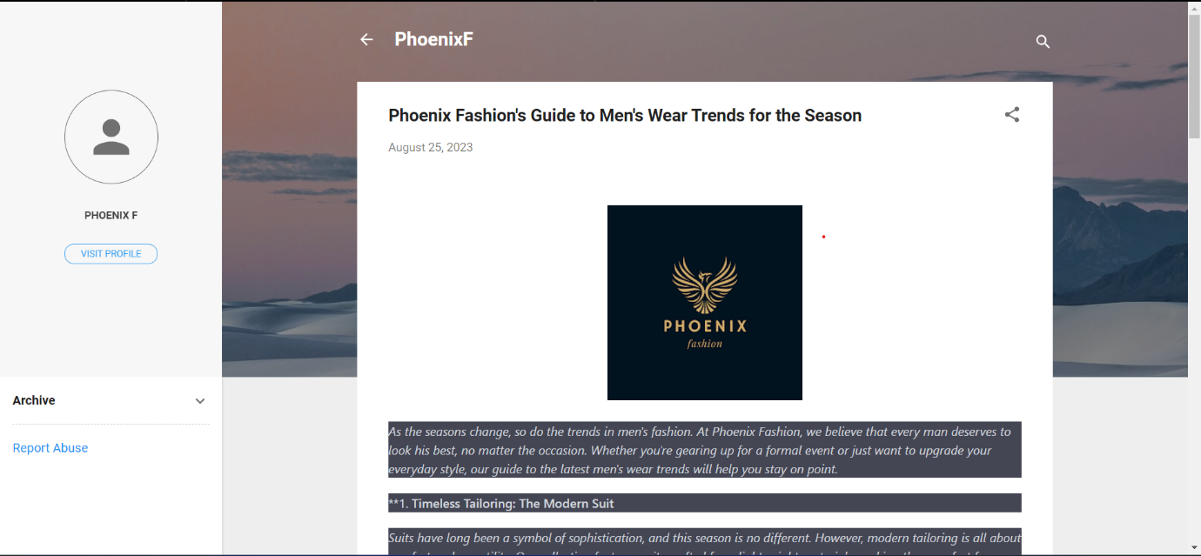

2.WordPress

Link: <https://ramkumar25092002.wordpress.com/2023/10/27/phoenix-f/>

